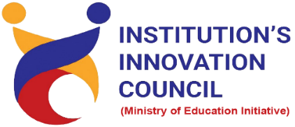
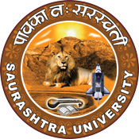
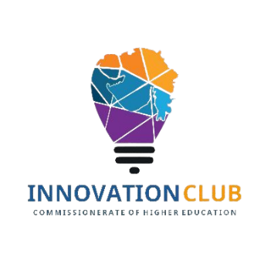

Institution's Innovation Council
Saurashtra University

Young Innovative Technologist

11 May 2022
At
Department of Physics,
Saurashtra University Campus, Rajkot
Contents
Saurashtra University – IIC 2
Event Schedule 2
Event Registration Link 2
Brief about Event 3
Key Points 3
Outcome 3
About the Speaker/Chief Guest 4
Connect Us: 5

Saurashtra University – IIC
The university is dedicated to instruction, research, and extending knowledge to the public (public service). Ministry of Education (MoE), Govt. of India has established ‘MoE’s Innovation Cell (MIC)’ to systematically foster the culture of Innovation among all Higher Education Institutions (HEIs). The primary mandate of MIC is to encourage, inspire and nurture young students by supporting them to work with new ideas and transform them into prototypes while they are informative years. Saurashtra University is one the Organization that have constituted the IIC to foster the vision of MoE and be a part for the promotion and development of innovation ecosystem.

Event Schedule

12:00

Welcome

12:05

Awarness Session

01:15

Q n A

01:30

Closing Ceremony

Event Registration Link

bit.ly/SUSEC-NTD

Brief about Event
This event organises in the form of expert lecture on Nano technology with some innovative examples. The expert lecture was conducted on the basic science in vicinity of nano science and nano science-based products have been demonstrated among the post graduate students and research scholar. This session also covered some scheme by government of India and government of Gujarat. In this expert lecture give motivation to be entrepreneur. In this session approx 25 students join in offline mode.

Key Points

During the session, below mentioned points were discussed:
- Nano science in current scenario
- Nano technology-based product in market
- How to do innovation from research work
- How to be entrepreneur
- Student start up policy
- Atma Nirbhar Bharat

Outcome

This expert lecture aware students to be entrepreneur and guide them to convert their research work in to market sustainable product.

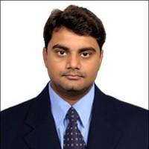
About the Speaker/Chief Guest

Dr. Davit B. Dhruv

Assistant Professor,
Department of Physics,
Saurashtra University

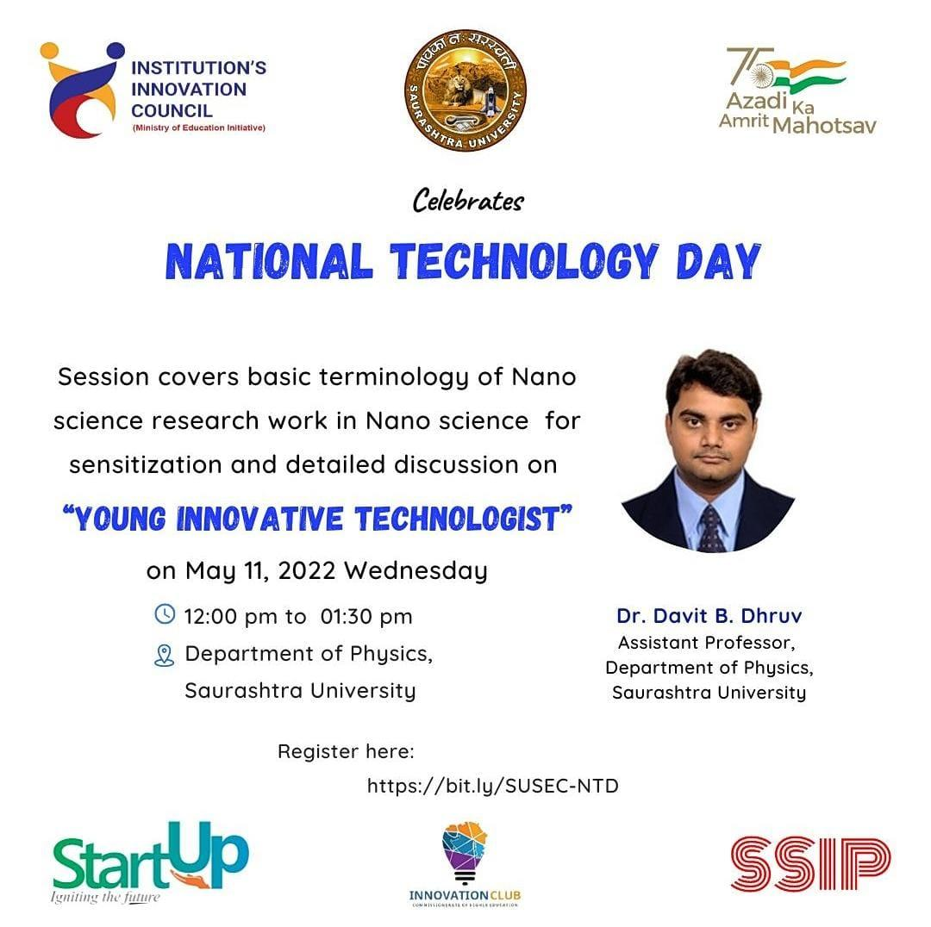

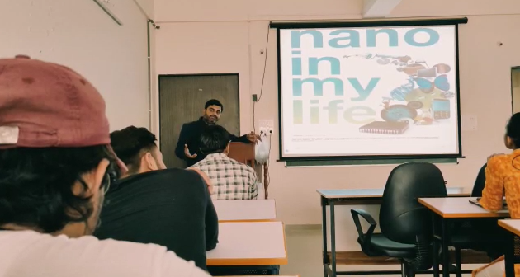
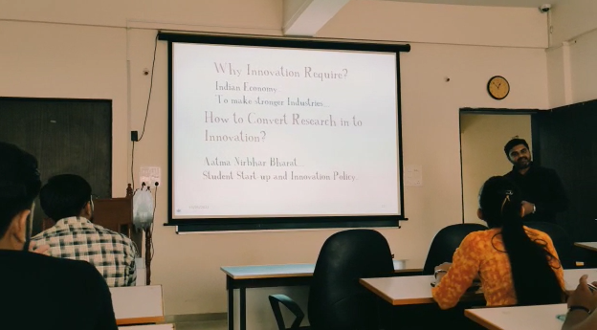

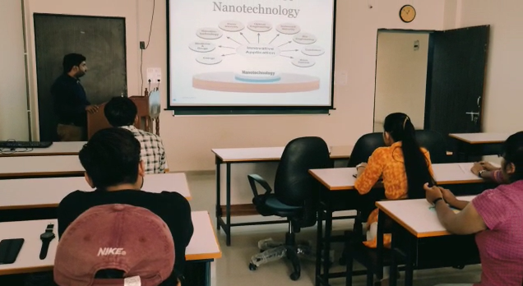

Connect Us:

https://www.linkedin.com/company/susec iic@sauuni.ac.in
https://www.facebook.com/iicsauuni bit.ly/SU-SSIP Location
https://www.instagram.com/susecrajkot

https://bit.ly/SUSEC-youtube

